**--Computer Science 3307A - Object-Oriented Design and Analysis 2021-2022 Fall Semester**

**University of Western Ontario, London ON, Canada, N6A 3K7**

**Magic Mirror**

**Group 20:**

Nathan Dinatale

Darwin Shiyi Liao

Peter Nicolaas Meijer

Nolan Morris

Yifei Zhang

**Instructor: Mike Katchabaw**

**Main Bootstrapper**

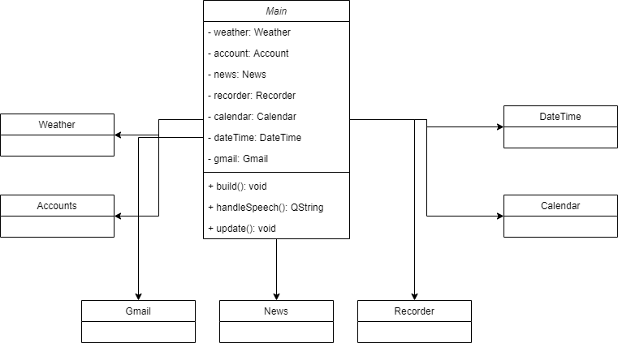

This is the main structure of the program. The main bootstrapper is responsible for creating and configuring all of the widgets that will be used in the product. It is also responsible for configuring the GUI and laying all of the information from those widgets in a visually appealing manner. Finally, it will be responsible for handling the speech-to-text system and passing off the command fetched from that class to the appropriate module.

This design was chosen as it allows for each of the widgets to be worked on nearly independently of all the others. All coupling would happen in this one class and, thus, it would allow for easy development of each module separately from the others. It will also make debugging easier since it will be easy to isolate which module is throwing errors. Moreover, it also allows us to make the project easy to grow and expand should time allow as it would be easy to simply connect a different module to it.

Below are the more detailed implementations of each of the modules. Please note that each of these diagrams are very subject to change throughout the course of development. For user stories, see the Jira board.

**Weather**

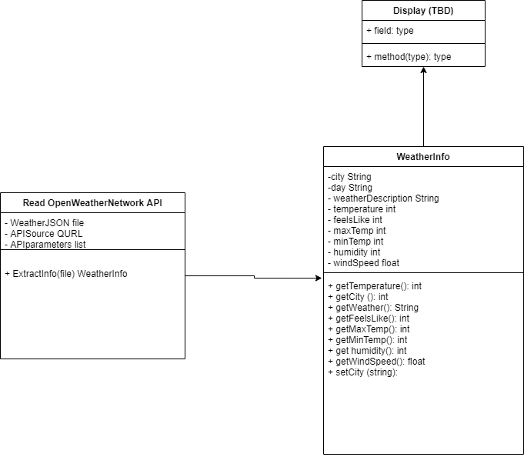

This module will allow us to talk to a weather API of our choosing in order to fetch the weather data for our desired location. It will then pass that information back to the main bootstrapper where it will be formatted and displayed accordingly.

**Accounts**

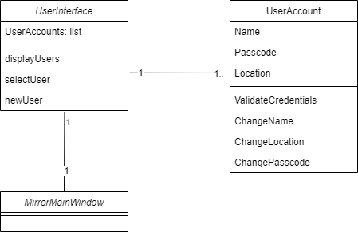

This module will allow for different google accounts to be set up in order to use various Google APIs for managing tasks such as the calendar and gmail feeds. This will be used in other modules as listed above and accessed through the main bootstrapper in order to avoid unnecessary coupling of the modules.

**Gmail**

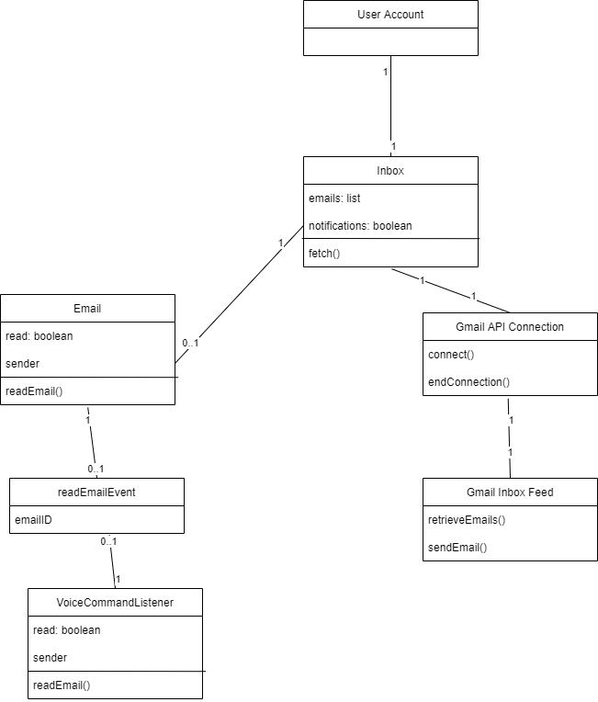

This module will allow the signed in user, from the user accounts, to see any new emails they might have received and it will allow them to view those emails barring the implementation of the speech-to-text module. The main bootstrapper will handle all of the configuration of the GUI from this module.

**News**

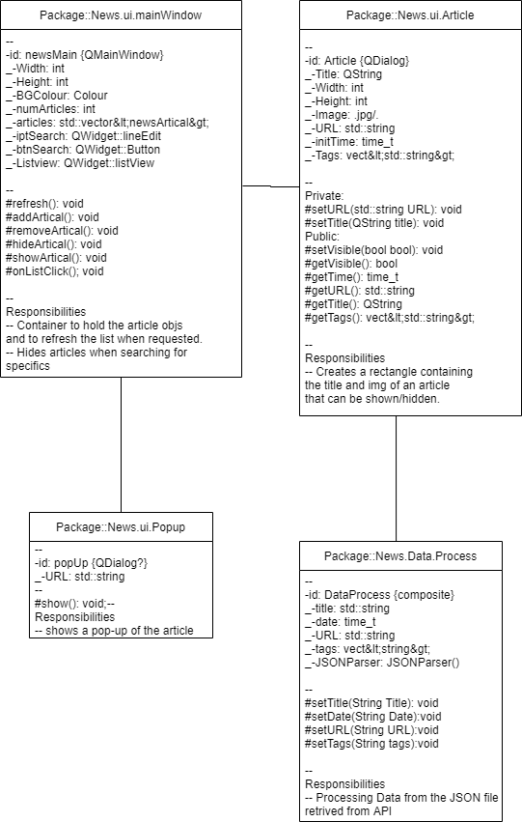

This module will fetch from a desired API some of the top news stories from the day thus far. It will be updated at certain intervals determined by the bootstrapper. The bootstrapper will handle all of the configuration of the GUI from this module.

**Date and Time + Calendar**

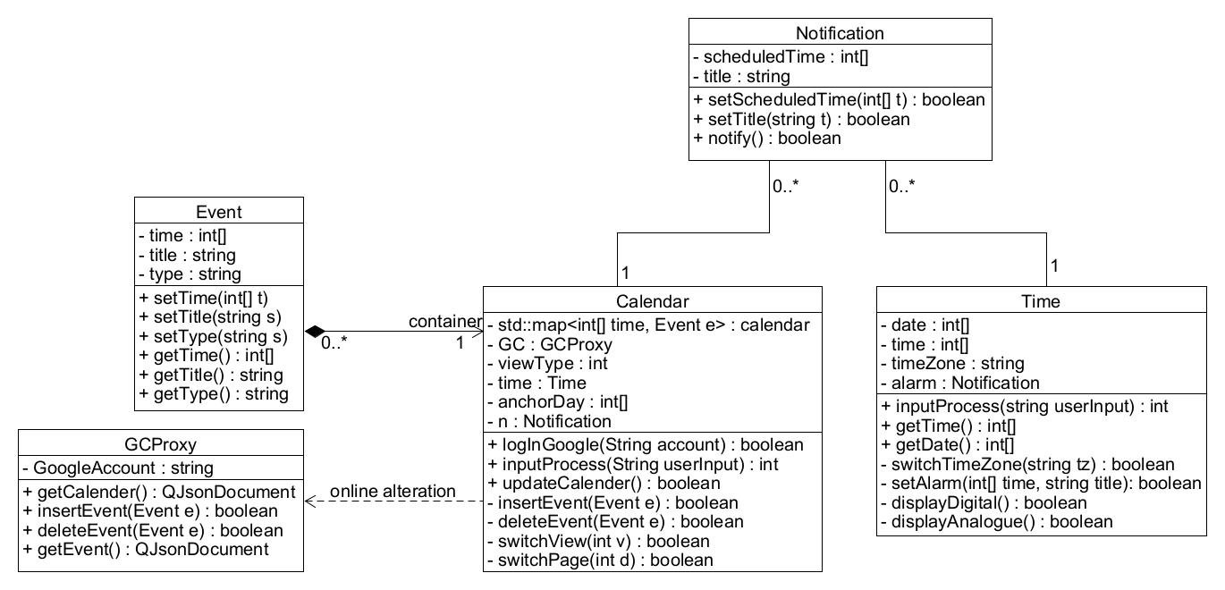

This module will allow the user signed in with a specific account to access their Google calendar to review events that they might have planned for the day or for the upcoming days. It will also be responsible for implementing a clock that the user can use to easily see the time. The bootstrapper will handle all of the configuration of the GUI from this module.

**Recorder**

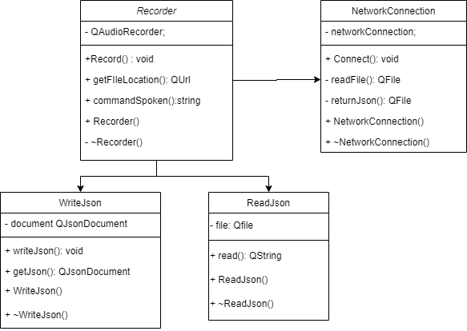

This module is responsible for implementing the Speech-to-Text system that may or may not be implemented depending on time constraints. The bootstrapper will be the only class that can call from this module in order to avoid unnecessary coupling and it will be responsible for delegating the returned text to the correct module.